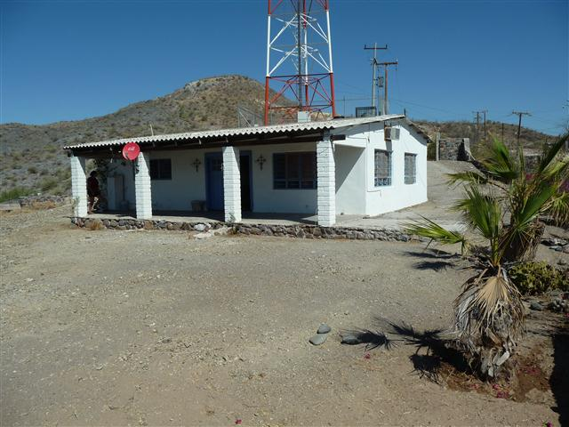
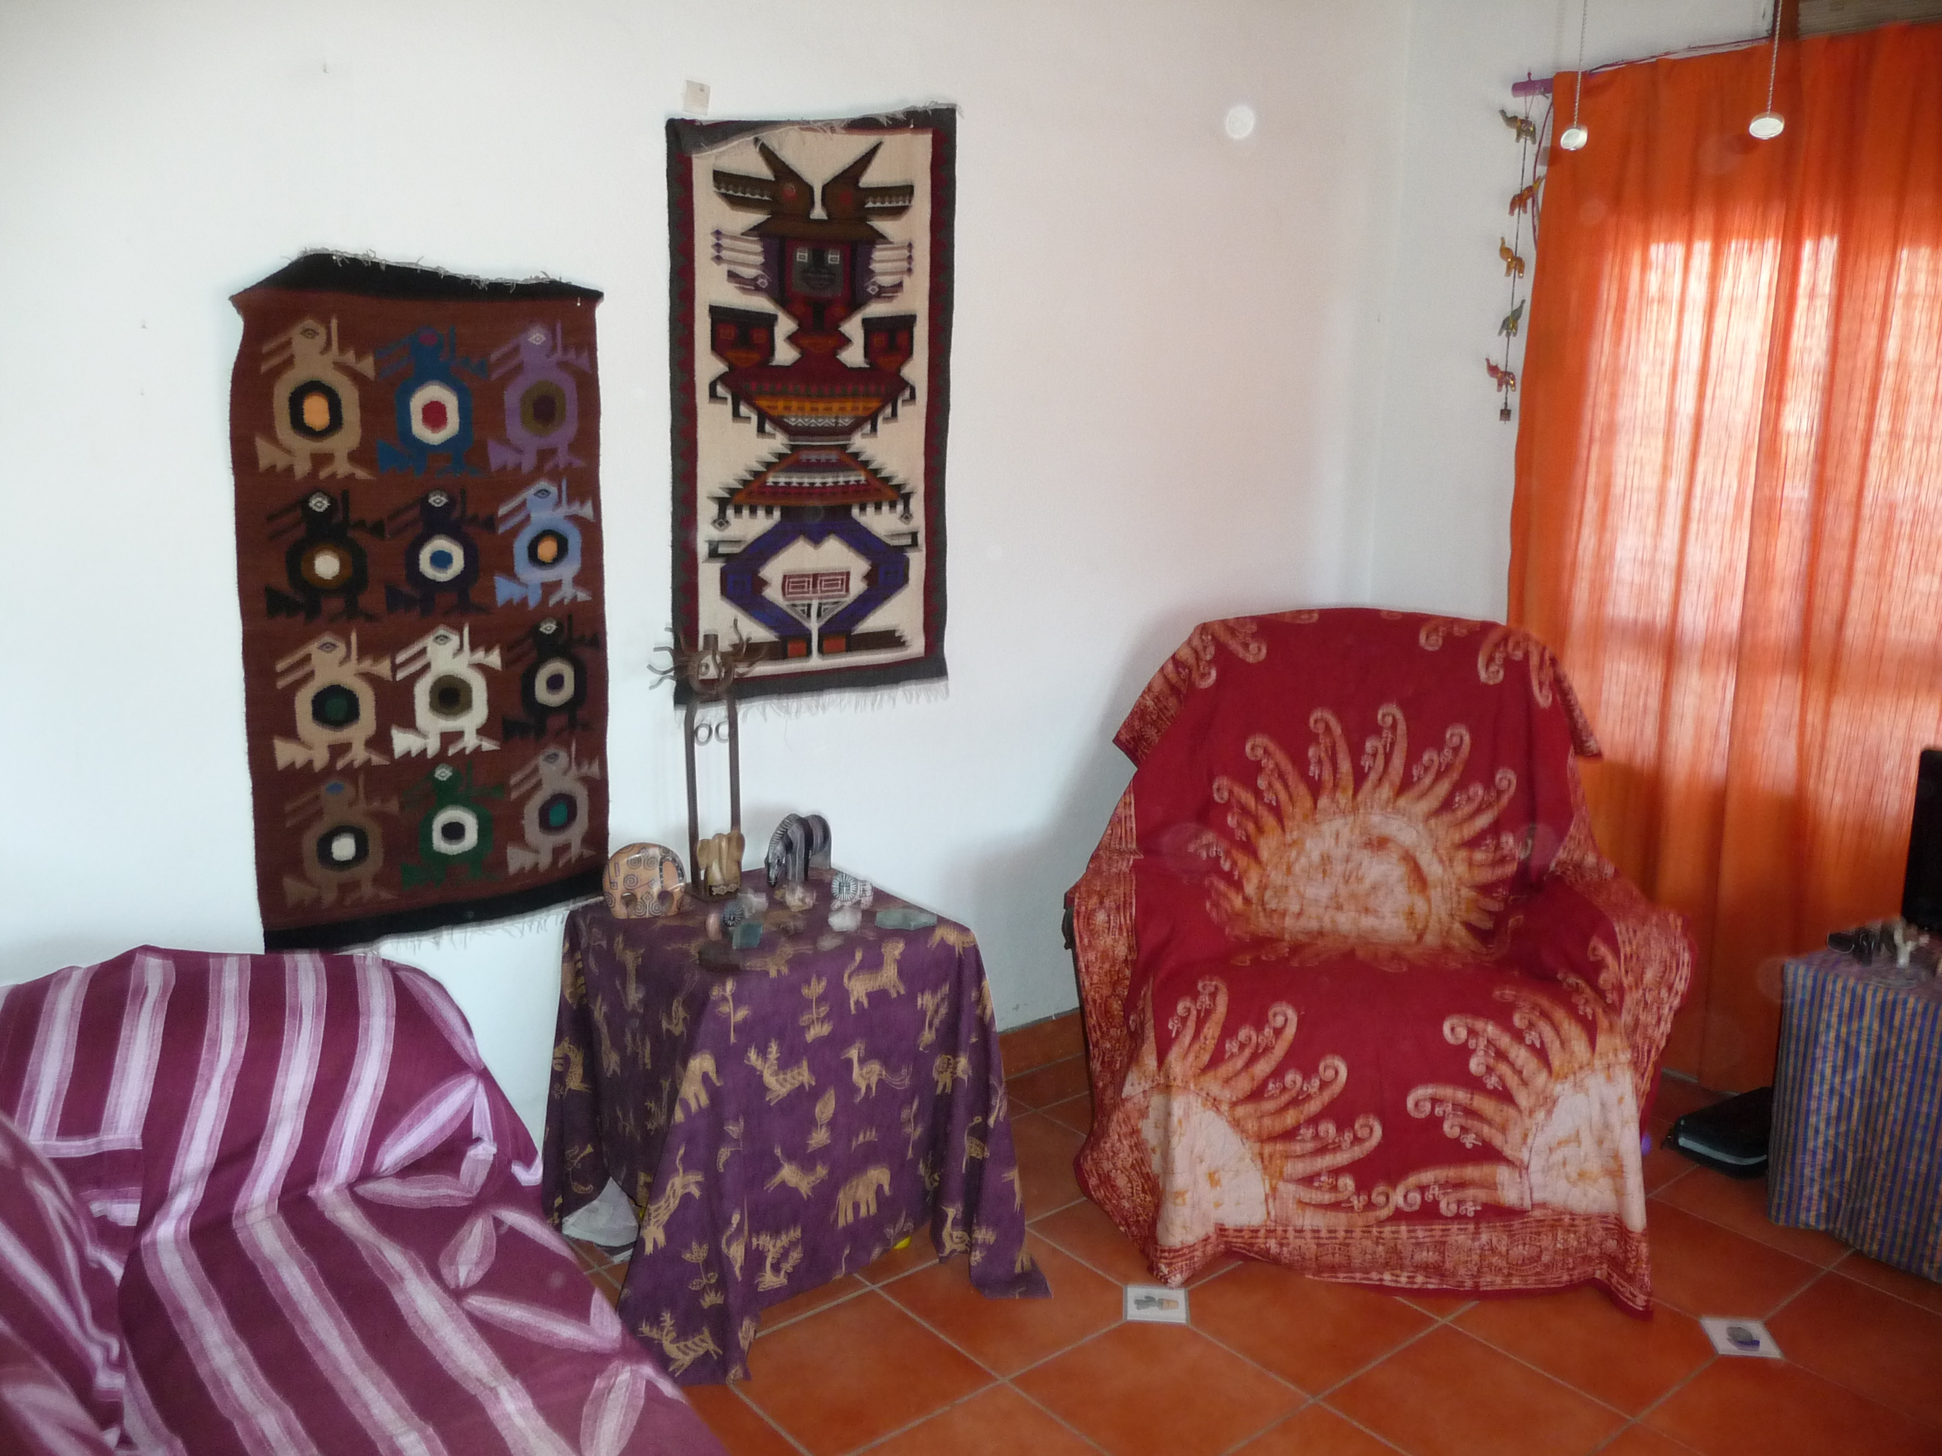
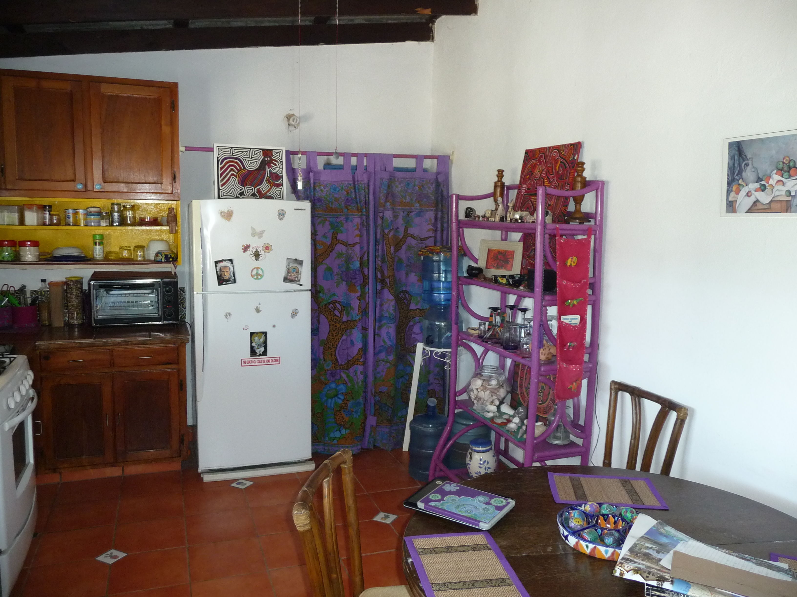
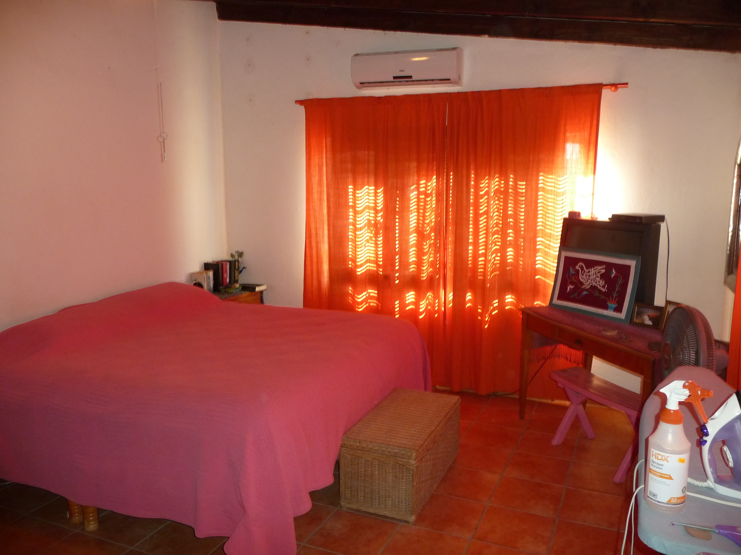
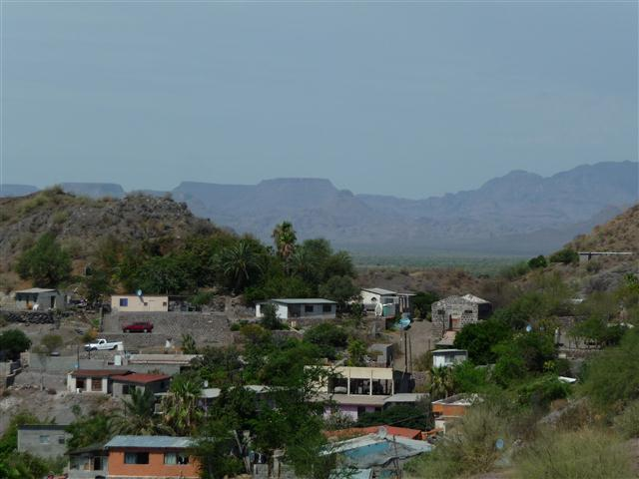
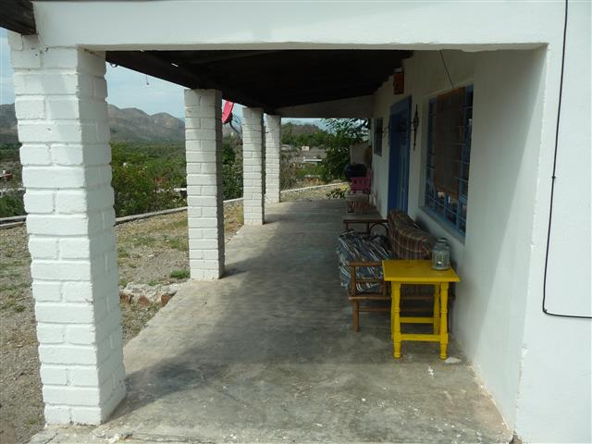
Owner dg h nt
$50,000 U.S.D.
Owner will Finance
Here’s a great opportunity to own a home right in the middle of town, here in Mulege This home has great features, Including a new Mini Split, New Hot Water Heater, New Electric Wiring, New water Pump Service, and a 220 A Service. Placed on a leveled 639 m2 view lot with Steward Title Insurance.

For more information on this, or other great homes contact Robin or Jose, we will answer any questions regarding buying and holding property here in Mexico.

Robin at:
robin@mulegeProperties.com.mx
615 153 1123
Jose at:
Cell 615 112 1092 phoenix1281@ymail.com
Quick Refrence:
Bedrooms………..2
Bathrooms……….1
Panoramic Views
In Town

